* **Common exception**
  + **MethodArgumentNotValidException, BindException**

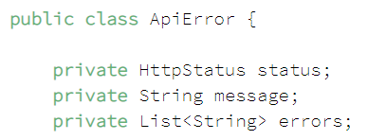 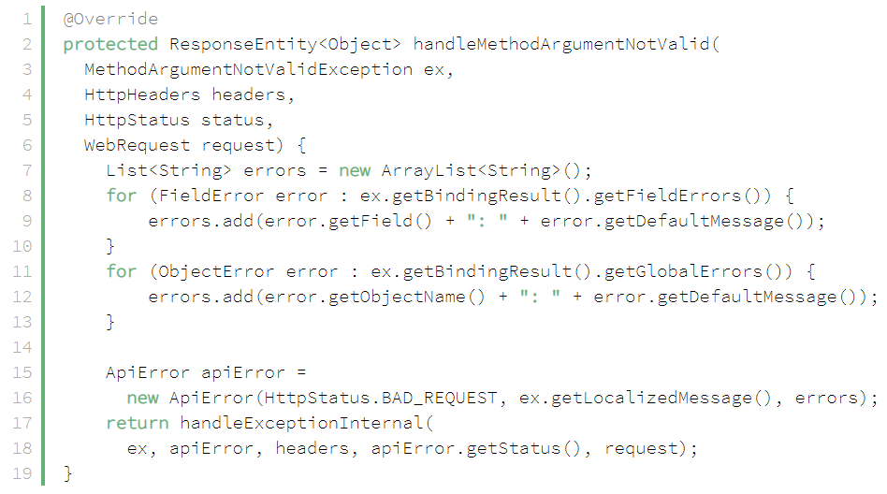

* + **MissingServletRequestPartException, MissingServletRequestParameterException**

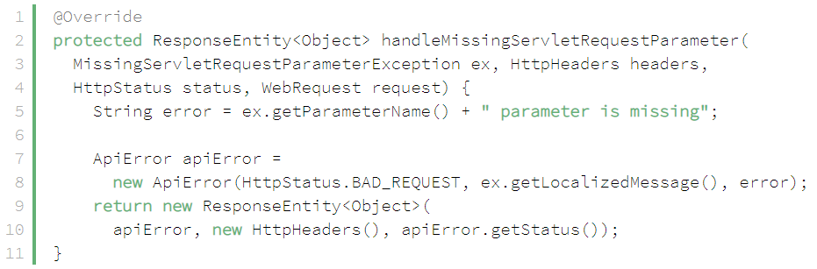

* + **ConstrainViolationException**

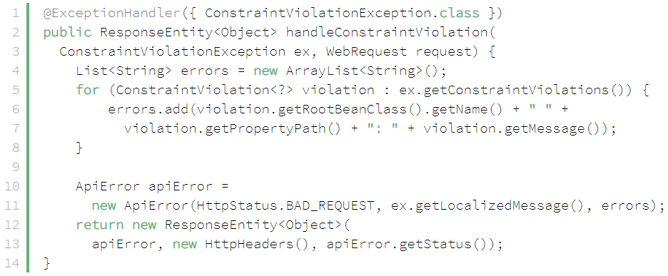

* + **TypeMismatchException, MethodArgumentTypeMismatchException**

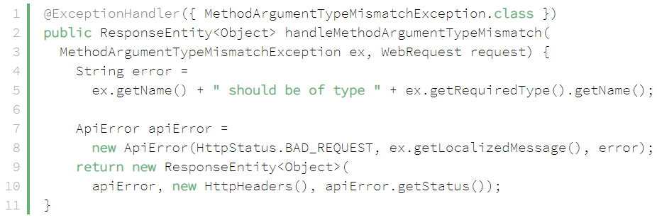

* **Test**



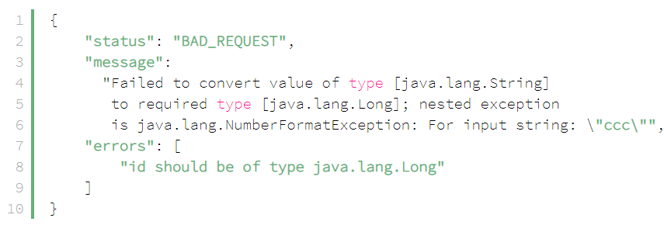

* + **NoHandlerFoundException**

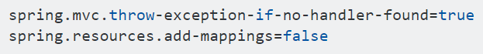

*application.properties File*

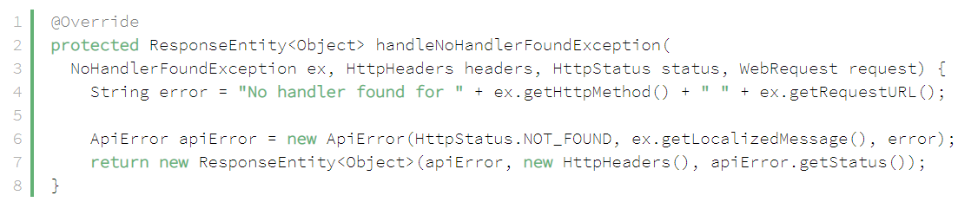

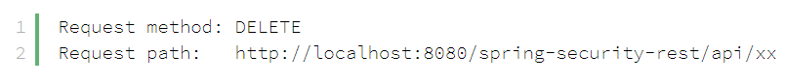

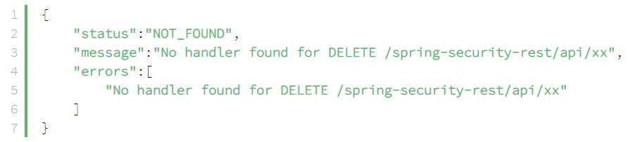

[*https://stackoverflow.com/questions/51048707/spring-boot-handling-nohandlerfoundexception/51050702*](https://stackoverflow.com/questions/51048707/spring-boot-handling-nohandlerfoundexception/51050702)

* + **HttpRequestMethodNotSupportedException**

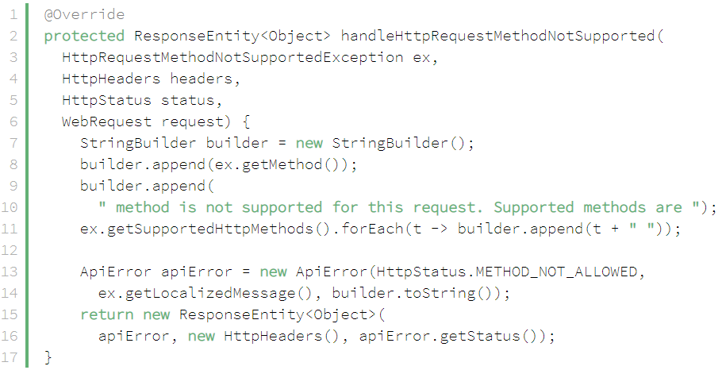



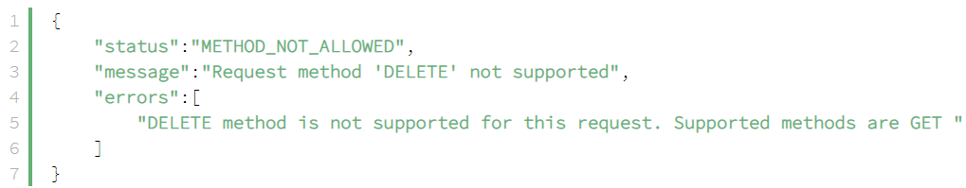

* + **HttpMediaTypeNotSupportedException**

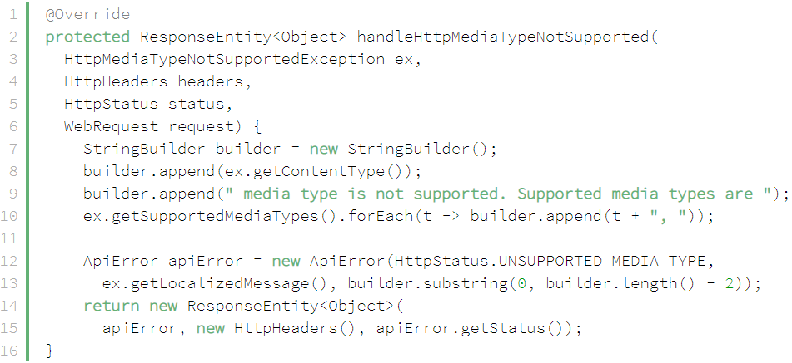

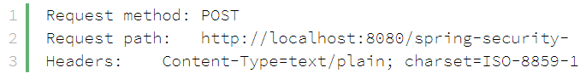

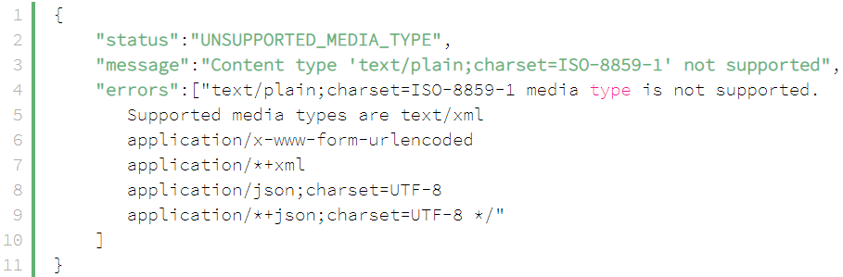

* **Reference**

<https://www.baeldung.com/global-error-handler-in-a-spring-rest-api>